Sharing inspiration 2019
STEM lab schools? Who are we? What can we achieve? What is the power of realisation?

STEM? What is STEM? Skills or content?

STEM curriculum? what is practical and what could the future be?

STEM content?…what is good STEM material? What is a good STEM lesson?

STEM CPD? How do we ensure quality? What is worthwhile? How do we use content portal?

STEM in the real world? What is digitisation and digitalisation? How do we digitise? How do we use coding and algorithms?
Solving real world problems. Realising the problem…making it real. Realisation…understanding…that is understanding all the component parts of a problem, the mathematics, the science and the technology and bringing them together to solve a problem.

The LED. The maths, the science, the technology.
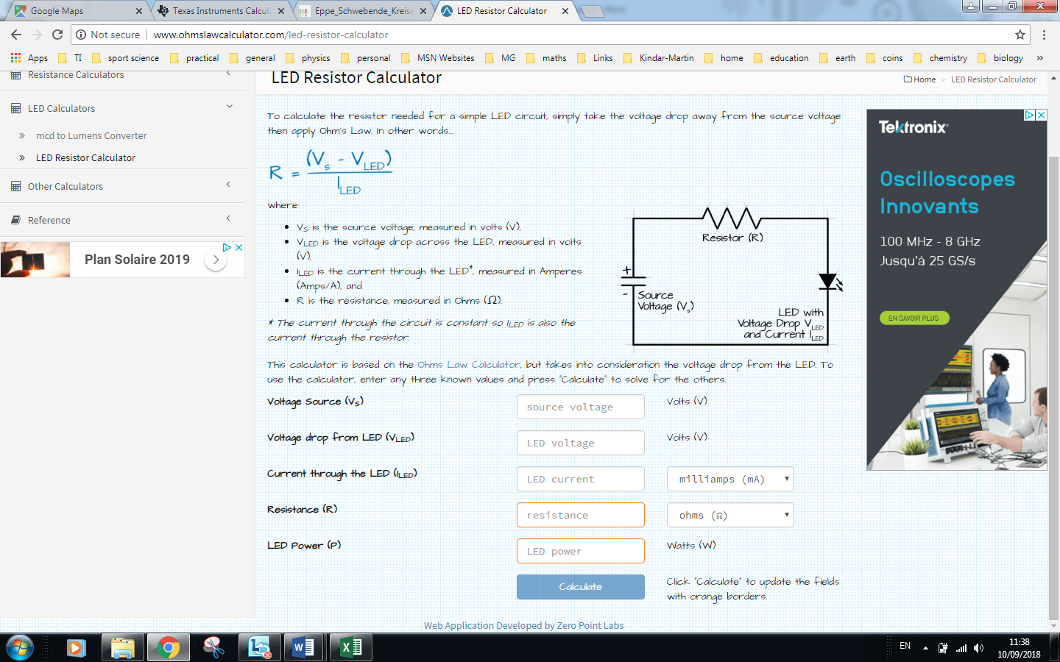
180 participants 12 parallel sessions 2x 12 x 3 hour power sessions
2x12x1.5 workshops 24
3x12x1 paper presentation 36

120/130 teachers 30 STEM lab schools

