Overview: |  |  | Goals:
This project explores the anatomy and electrical physiology of the human heart. Students will model the four chambers of the heart and the sequences of contractions required to pump blood. The sinoatrial (SA) and atrioventricular (AV) nodes are simulated using LEDs connected to the TI Innovator Hub. A temperature sensor is used to model the autonomic control system of the heart. As an extra challenge, students can model an AED and use it to rescue their model heart from a ventricular fibrillation event. The electricity in this activity is safe for students and poses no risk of shock. |  |  | Students will…  - build a physical model of the human 4 chamber heart.  - electrically connect the Hub to their model and write a program that simulates the electrical activities of the AV and SA nodes.  - build and model an AED to reestablish sinus rhythm after a ventricular fibrillation event.
Project Background:
The heart is a muscular organ within the left side of the human chest, which pumps blood through the circulatory system of the body. Circulating blood carries nutrients and oxygen from the intestines and lungs; it also transports metabolic wastes and carbon dioxide to the liver, kidneys and lungs. The heart is an amazing organ that beats every moment a person is alive. The heartbeat is created by two packets of cells within the heart called the sinoatrial (SA) node and the atrioventricular (AV) node. These two nodes make a natural pacemaker that produces an electrical impulse that travels through the heart and causes the muscle to contract in a rhythm that forces the blood to move through the four chambers, lungs and body. In a healthy person, the SA and AV nodes respond to the body’s need for metabolites and will speed up or slow down the heart rate as needed to keep the body healthy.  Some people however, have disease in the SA and AV nodes that can cause the heart to beat incorrectly, thus causing stress and possible death in the individual. For people who have this disease, an artificial pacemaker may improve their quality of life. The artificial pacemaker is a medical device that consists of a battery, a microcontroller and electrodes that is programmed to produce the rhythmic electrical impulses required to keep the heart beating regularly. The artificial pacemaker is inserted under the skin of the chest and the electrodes are inserted into the heart in areas that stimulate the appropriate area. The cardiologist can then program the pacemaker with software that is correct for the individual.  *All images substantially modified from original source images at https://commons.wikimedia.org |  |  |  |  |  |  | 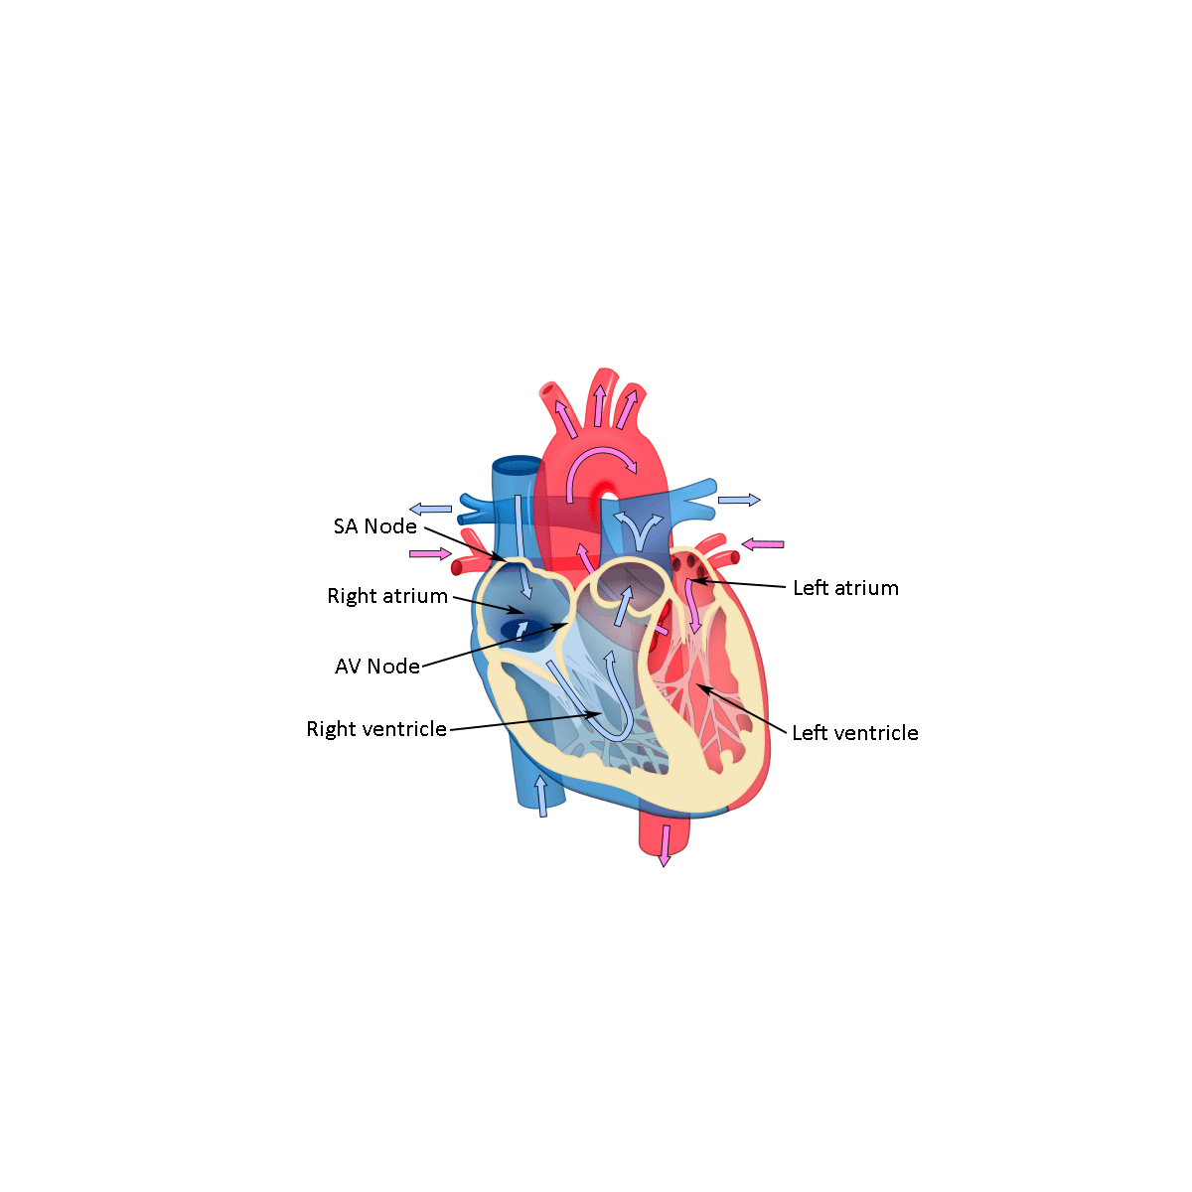  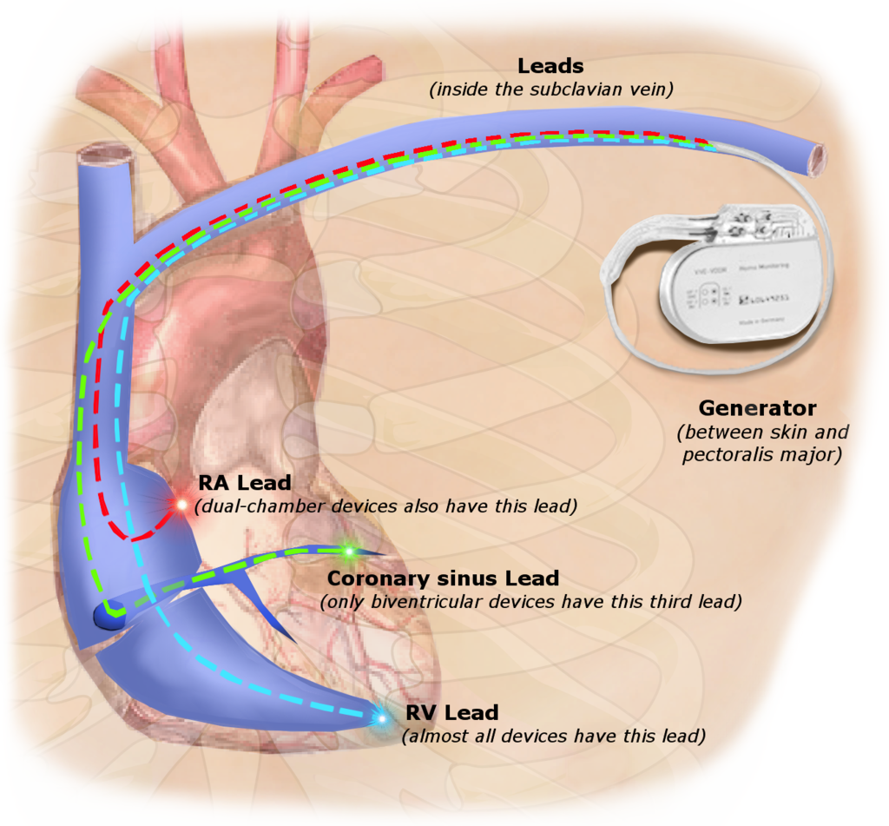
Command Background:
Supplies and Equipment:
- TI Nspire CX and Innovator Hub  - 4 x M/F Jumper Wires  - 1 x M/M Jumper Wires |  | - 4 x LED  - 4 x Toothpicks with labels  - 3oz. conductive Play-Doh do not use plasticine or modeling clay  - Temperature sensor
Setup Project:
The four separate chambers of the heart are formed using electrically conductive Play-Doh. The heart’s electrical system, the SA and AV nodes, are modeled using the Innovator Hub and four LEDs controlled by a TI-BASIC program. The model should include these events:  - An electrical event causes the right atrium to push blood into the right ventricle.  - An electrical event causes the right ventricle to contract and force blood into the lungs via the pulmonary artery.  - An electrical event causes the left atrium to contract and force oxygenated blood from the lungs, into the left ventricle.  - An electrical event causes the left ventricle to contract and force oxygenated blood through the body.  - Produce an EKG heartbeat sound once per cycle.  - A temperature sensor to represent physiological input to the autonomic nervous system (ANS). In this model, increasing the temperature of the sensor should increase the heart rate. |  |  |  |  |  |  |  | 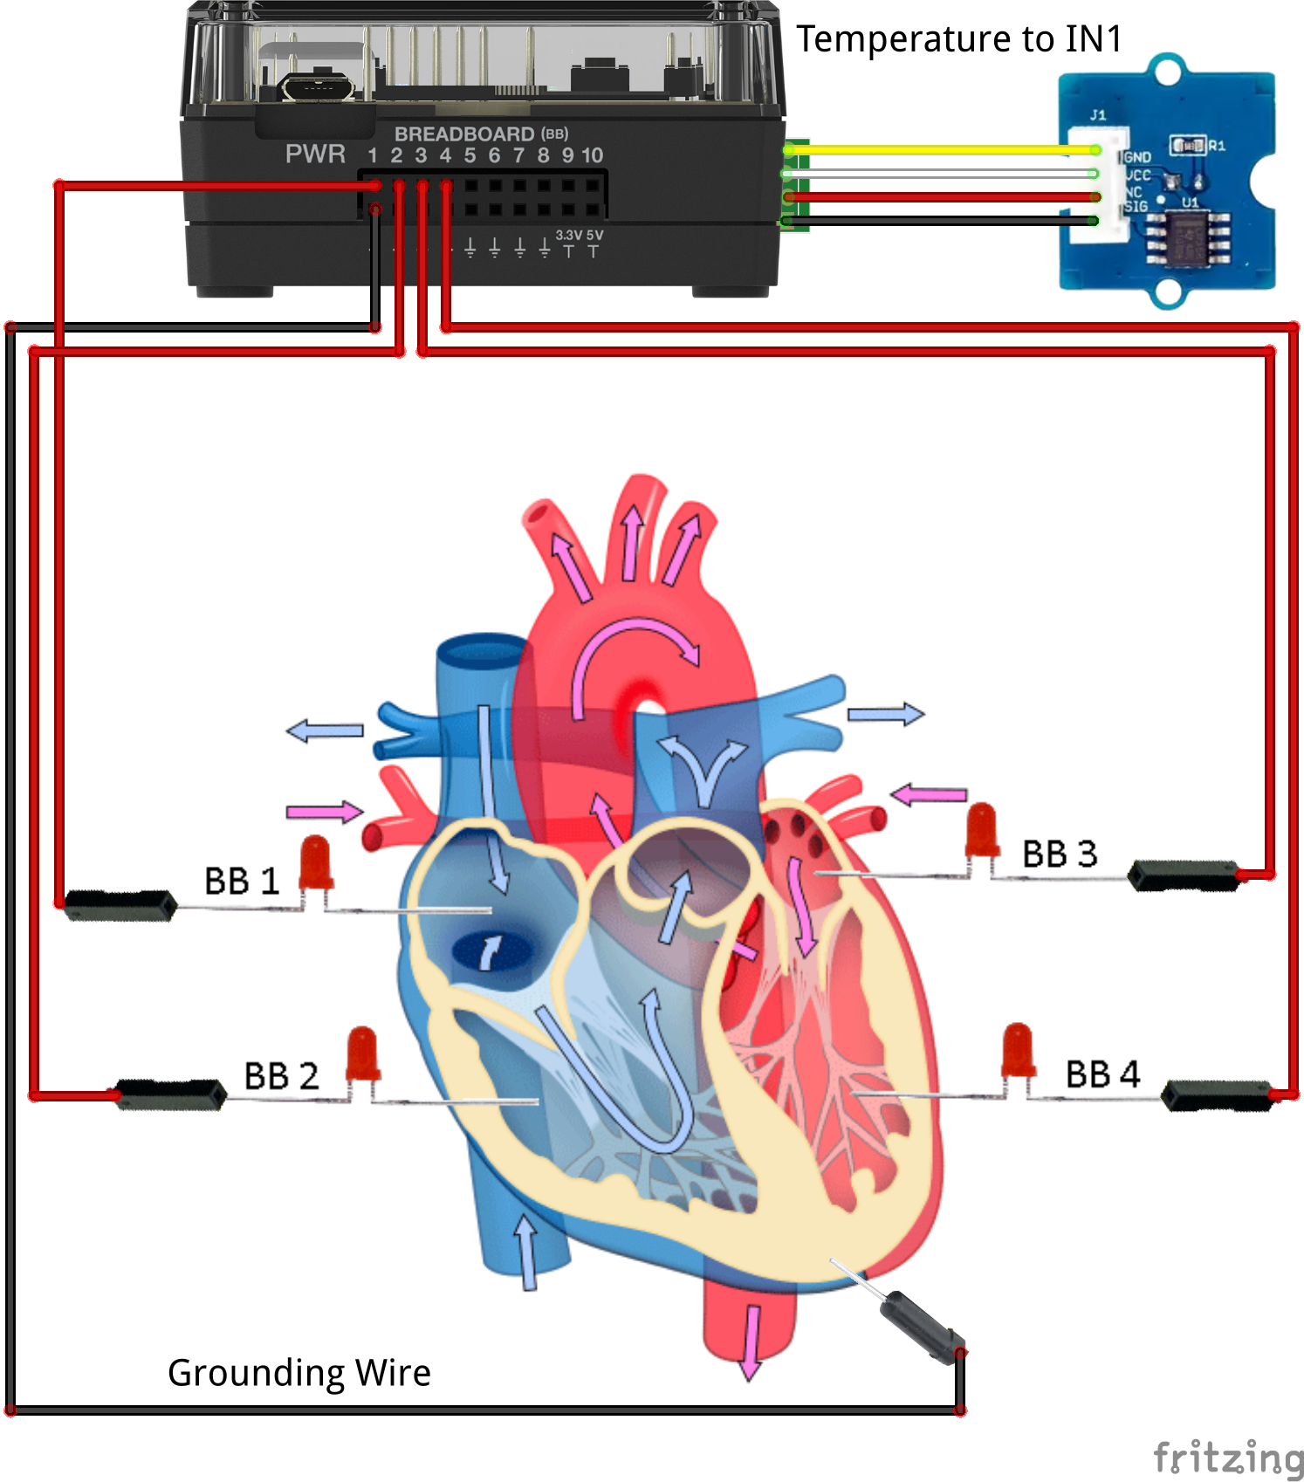
The Student Activity | The Teacher Activity
Sit in small groups of 2-3 students with calculators and supplies for this activity. | Introduce the overall engineering goal of the project and how the model should represent some of the electrical aspects of the human heart. The project will be built stepwise with three student challenges. Discuss possible prototypes. Have students draw a picture of their prototype and describe how it will work. Share ideas with class.
Challenge 1: Make an LED connected to BB1 blink at a rate of 2 Hz (flashes per second) for 10 seconds. | Guidance during challenge 1:  - Review concepts from 10 Minutes of Code for the Innovator Hub including the For-EndFor loop.  - Review the Mood Ring project as a basic example of feedback and control.  - Demonstrate to students how to insert an LED into the Hub. The anode (+) should insert into the BB 1 hole while the cathode (-) should insert into the ground hole.  - Show students how to open a new file and insert a program named “blink”.  - Inform students of the required commands to accomplish the task.  - You may wish to challenge students to try to make the LED blink at a rate of 5 Hz for 20 seconds. |  |  |  |  | 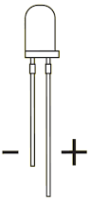  Send “CONNECT LED 1 TO BB 1”  For n,1,20  Send “SET LED 1 ON”  Wait .25  Send “SET LED 1 OFF”  Wait .25  EndFor
Challenge 2: Make four LEDs connected to BB 1 thru BB 4 blink in sequence ten times. Make the Hub beep like an EKG machine after each cycle of the four LEDs. The program should run for at least 30 seconds. | Guidance during challenge 2:  - Be sure students insert the LEDs correctly with the polarity identified in the previous diagram.  - Discuss the requirement that each LED object 1-4 has a CONNECT command to a unique BB pin.  - Discuss the concept of nested loops (loop within a loop).  - Be sure the two loops have different index variables.  - Notice the use of the eval() statement, this substitutes the value of the variable into the Hub command.  - The sound command should be short. Have students explore frequencies and durations to produce the desired effect. |  |  |  |  | Send “CONNECT LED 1 TO BB 1”  Send “CONNECT LED 2 TO BB 2”  Send “CONNECT LED 3 TO BB 3”  Send “CONNECT LED 4 TO BB 4”  For n,1,15  For c,1,4  Send “SET LED eval(c)ON”  Wait .25  Send “SET LED eval(c)OFF”  Wait .25  EndFor  Send “SET SOUND 440 TIME .1”  EndFor
Challenge 3: Build a model of the Human four chamber heart using the M-F wires to extend the LED to the Play-Doh. Label each chamber with the appropriate name. Test the model using the program from challenge 2. | Guidance during challenge 3:  - Play-Doh material is conductive due to the salt and water content. The grounding wire may be plugged into any of the 4 Play-Doh chambers.  - Be sure the LEDs are inserted with the short  cathode (-) lead inserted into the Play-Doh and the long anode (+) lead plugged into the receptacle of the jumper wire.  - Be sure all four of the chambers are touching to make electrical connection.  - Explain the flow of blood through the heart and the required order of muscle contractions from each chamber. Discuss how the SA and AV nodes send electrical impulses to the chambers to keep the sinus rhythm. |  |  |  |  | 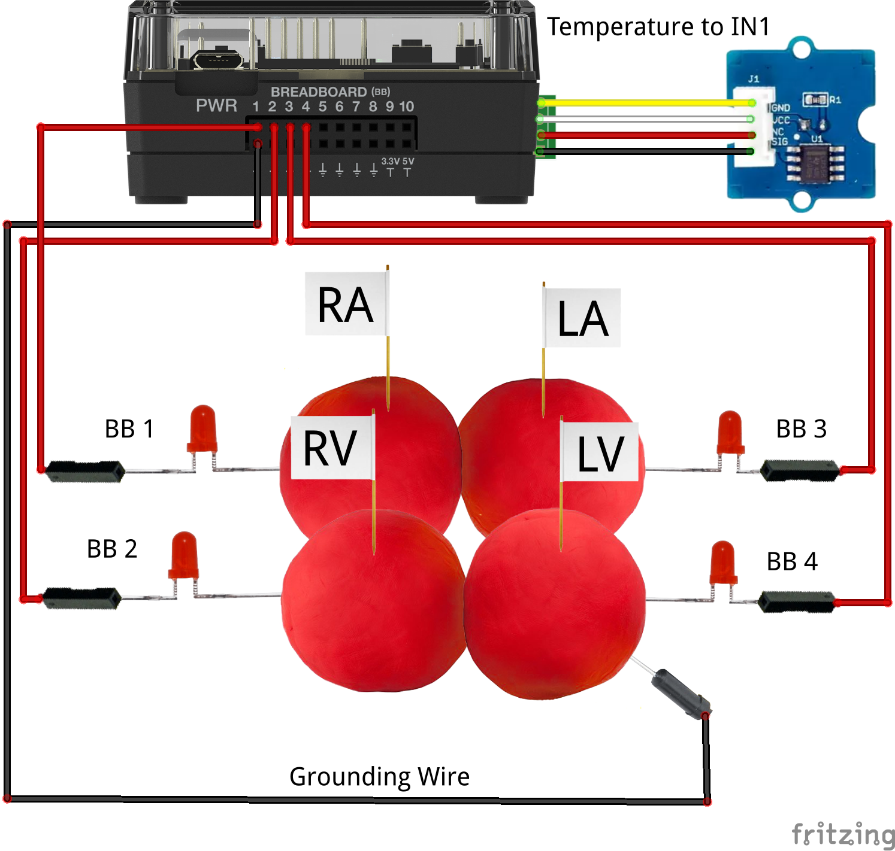
Challenge 4: Use the Grove temperature sensor to modify the heart rate. Change the program from Challenge 3 such that when temperature goes up, heart rate goes up. | Guidance during challenge 4:  To modify the previous program, students must:  - Insert a Grove temperature module into IN 1.  - CONNECT the TEMPERATURE object to IN 1.  - Ensure temperature is read each turn of the outer loop. Be sure of correct placement in the program.  - A variable called “period” has been inserted into the program which alters the wait time. This variable changes the LED flash rate.  - Use an If-ElseIf-EndIf decision tree to modify the wait period (period is reciprocal of the heart rate) based on the temperature of the sensor.  - Explain how the autonomic nervous system (ANS) detects external temperature and then controls physiological responses such as shivering, perspiration and heart rate based on the perceived temperature. Describe how the SA and AV nodes are part of the ANS and thereby control the heart rate. |  |  |  | Send “CONNECT LED 1 TO BB 1”  Send “CONNECT LED 2 TO BB 2”  Send “CONNECT LED 3 TO BB 3”  Send “CONNECT LED 4 TO BB 4”  Send “CONNECT TEMPERATURE 1 TO IN1  For n,1,10  Send “READ TEMPERATURE 1”  Get t  If t≤23 then  period =.25  ElseIf t>23 and t≤24  period:=.2  ElseIf t>24  period:=.15  EndIf  For c,1,4  Send “SET LED eval(c)ON”  Wait period  Send “SET LED eval(c)OFF”  Wait period  EndFor  Send “SET SOUND 440 TIME .1”  EndFor
Extra for Experts: Modeling an Automatic External Defibrillator (AED)
Occasionally, some people suffer a life-threatening condition called ventricular fibrillation. This condition spontaneously arises in a person’s heart when the electrical activity from the SA and AV nodes becomes electrically disorganized and the ventricles of the heart quiver erratically instead of regularly pulsing and pumping blood. When ventricular fibrillation occurs in a person, the heart’s electrical system needs to be rebooted or else the person will likely die. One method of reestablishing the heart’s electrical rhythm is with an automatic external defibrillator (AED). An AED is a portable electronic device that senses the patient’s heart activity and then smartly programs a series of electrical shocks that are delivered across the heart in an effort to reestablish the normal rhythm. The AED has electrically conductive pads that are placed on the patient’s chest; it then analyzes the electrical activity of the heart and delivers the appropriate electrical shock across the heart. |  |  |  | 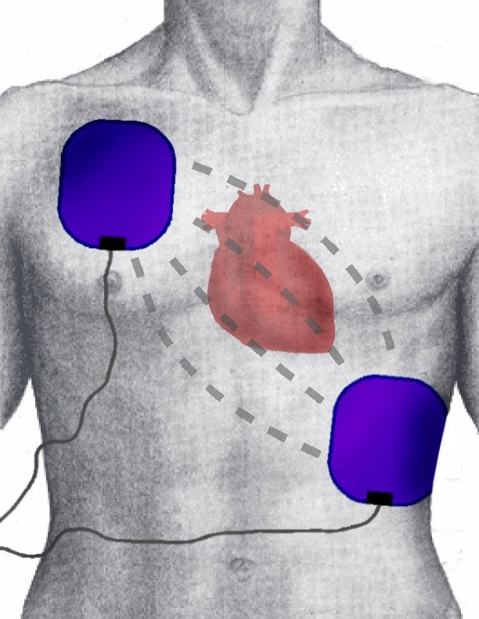  Placement of AED pads on a patient’s chest
Challenge 4: Build a model of AED paddles and write a program that sounds a tone when the two paddles touch the Play-Doh of the model heart. | Guidance during challenge 4:  - Aluminum foil attached to the lead of a M/M jumper wire.  - A small piece of tape may be used to ensure good electrical contact between the wire pin and the foil.  - Fold the foil over a few times to make a rigid paddle.  - Paddle should be about one square inch.  - Encourage students to try alternate materials for building their paddles.  - Once paddles are constructed, plug one paddle into the BB6 of the breadboard connector and the other into BB5.  - The SET DIGITAL.OUT 1 TO HIGH command turns on BB6 pin to 3.3Volts. The READ ANALOG.IN A command measures the voltage on pin 5 and returns a value between 0 and 16,384. When the two paddles are connected via the Play-Doh circuit, the ANALOG.IN pin “sees” the 3.3Volts from the DIGITAL.OUT pin and returns a value around 10,000. A program that monitors the ANALOG.IN number can “know” when the paddles are touching the heart. |  |  | 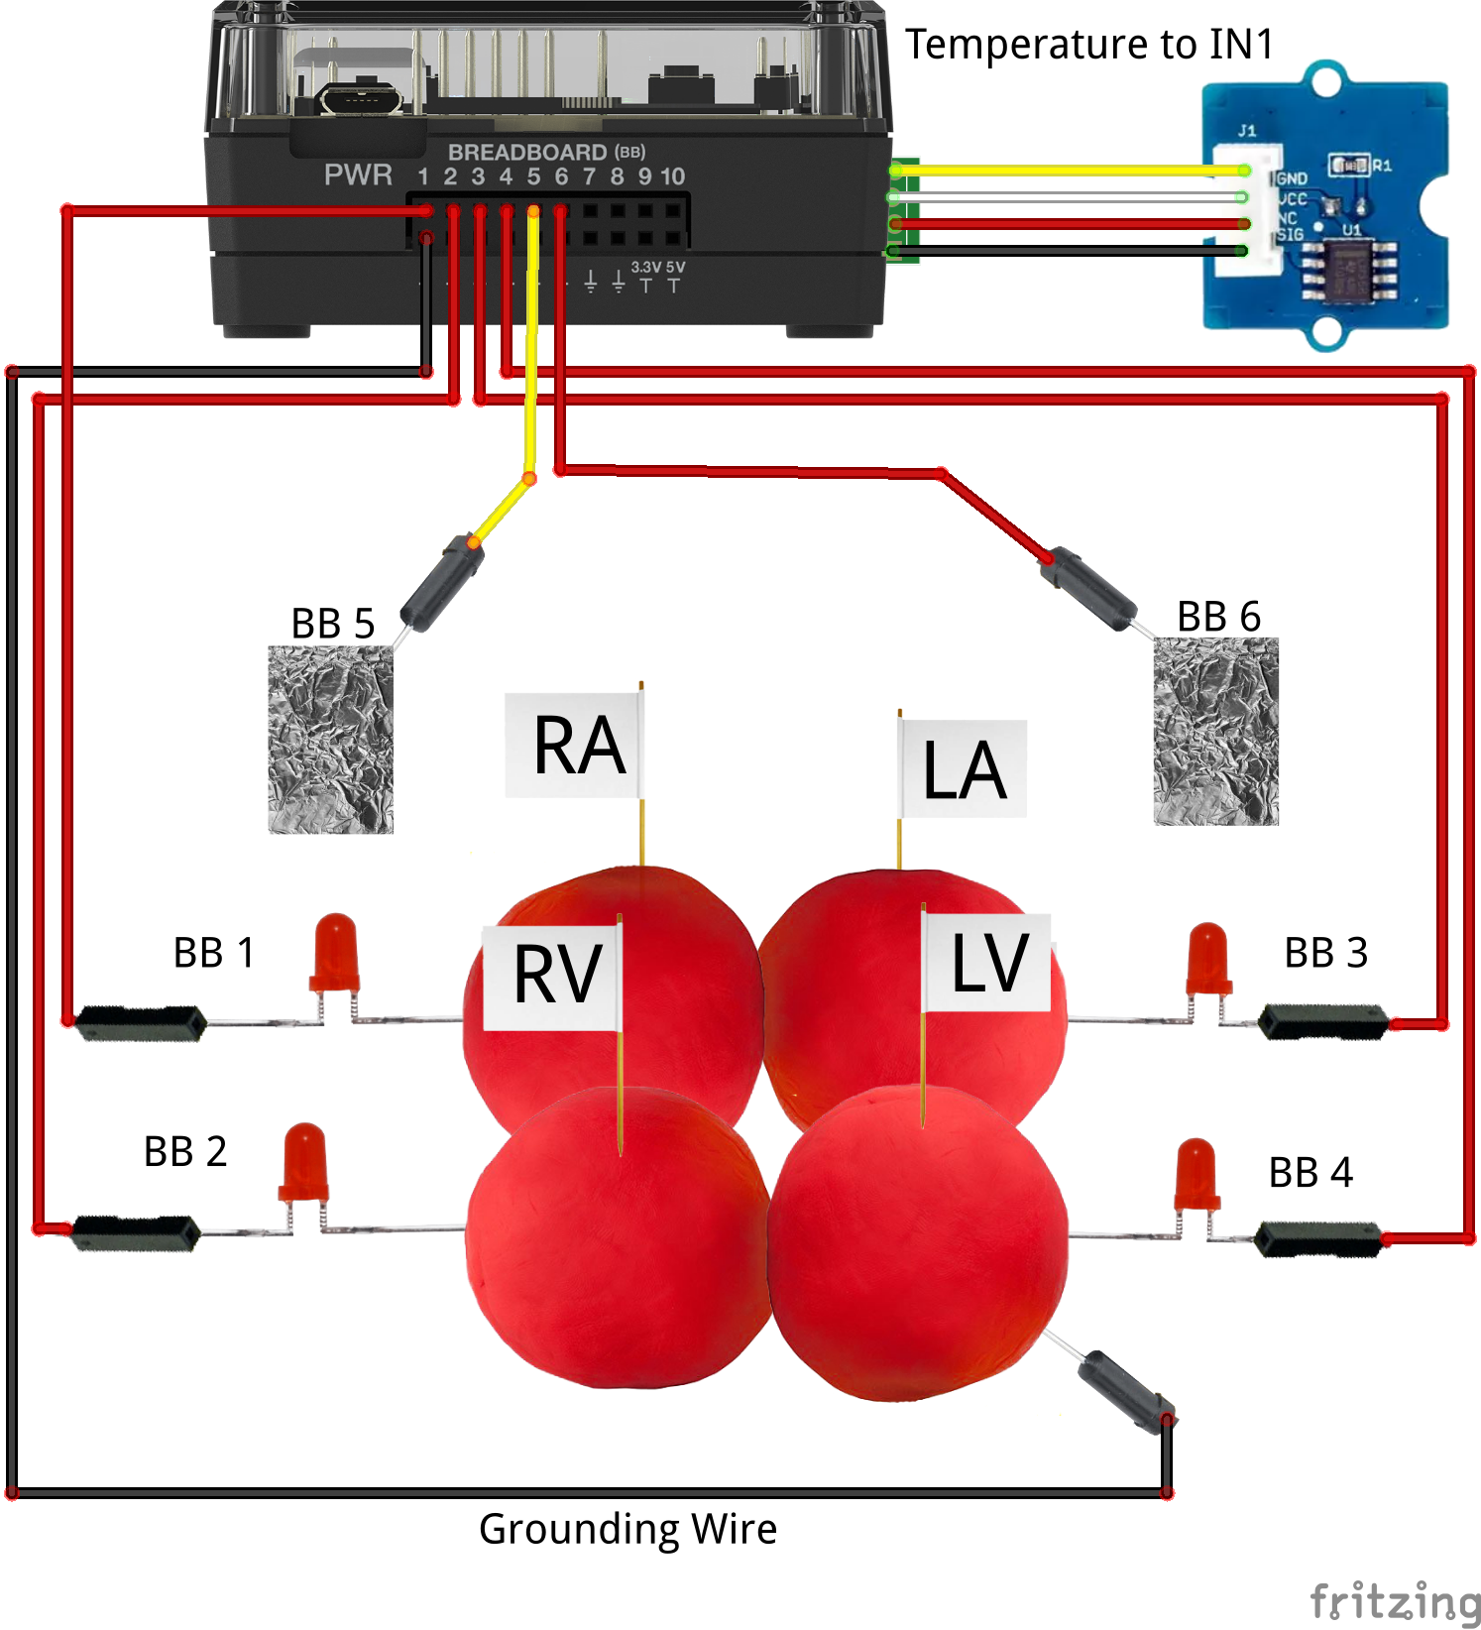  key:=" "  Send "CONNECT ANALOG.IN 1 TO BB5"  Send "CONNECT DIGITAL.OUT 1 TO BB6"  Send "SET DIGITAL.OUT 1 TO HIGH"  While key≠"esc"  Send "READ ANALOG.IN 1"  Get a: DispAt 3,"value = ",a  If a>7000 Then  Send "SET SOUND 500 TIME .1"  EndIf  key:=getKey()  EndWhile
Challenge 5: Write a program that reuses the code from Challenge 2 to make a normal heart beat for 5 beats. After the 5 beats, simulate ventricular fibrillation by playing a flat line tone. Modify the code from Challenge 4 to monitor the AED paddles and wait until the paddles touch the heart. After the paddles touch the heart, resume normal rhythm for an additional 5 beats. | Guidance during challenge 5:  - This final challenge requires students to put together all of the skills they have learned.  - The example code also requires that all of the CONNECT statements from the previous challenges be included. See accompanying example code.  - The essential part of this code is monitoring the ANALOG.IN port in a While loop. The While loop test expression is true until the reading exceeds 7000 due to the voltage from the DIGITAL.OUT pin. Be sure the test variable, e.g “a” is initialized to zero before the while loop is used.  - Encourage students to reuse “known-to-work” code in new projects.  - Students may find that drawing a flow chart of the program on paper before they actually write the code is helpful.  - This challenge is a good opportunity to discuss the electrical activity of the heart with the electrical activity of the Hub and Play-Doh model.  - Encourage students to take liberty to be creative by adding sounds, messages and other elements to their program.  - Consider building an enclosure for the Play-Doh. Particularly if a 3D printer is available. |  |  | a:=0  Send "SET DIGITAL.OUT 1 TO HIGH"  DispAt 3,"Heart is beating normally"  For n,1,5  For c,1,4  Send "SET LED eval(c) ON"  Wait 0.25  Send "SET LED eval(c) OFF"  Wait 0.25  EndFor  Send "SET SOUND 440 TIME .1"  EndFor  DispAt 3,"Heart is is in ventricular fibrillation!"  Send "SET SOUND 440 TIME 100"  While a<7000  Send "READ ANALOG.IN 1"  Get a  Wait 0.1  EndWhile  Send "SET SOUND 0"  DispAt 3,"Heart is back to normal!"  For n,1,5  For c,1,4  Send "SET LED eval(c) ON"  Wait 0.25  Send "SET LED eval(c) OFF"  Wait 0.25  EndFor  Send "SET SOUND 440 TIME .1"  EndFor
Command | Example | Behavior
CONNECT LED <number> TO <bread board pin> | “CONNECT LED 1 TO BB1” | Associates an LED plugged into BB 1 on the Hub with a software object named LED 1.
CONNECT TEMPERATURE <number> TO <port> | “CONNECT TEMPERATURE 1 TO IN 1” | Associates a Grove temperature module plugged into port IN 1 on the Hub with a software object named TEMPERATURE 1.
SET LED <number> TO <state> | “SET LED 1 TO ON” | Switches the LED associated with the corresponding “CONNECT LED 1 …” command to ON. The state may also be OFF.
READ TEMPERATURE <number> | “READ TEMPERATURE 1” | Reads the grove temperature module associated with the corresponding “CONNECT TEMPERATURE 1 …” command in centigrade degrees. A Get command must immediately follow the READ command.
Get <variable> | Get T | Gets the value returned from the Hub from the previous READ command and stores the value into the variable named “T”.
SET SOUND <frequency in Hz> TIME <duration in Sec> | “SET SOUND 440 TIME 3” | Sets the speaker on the Hub to make a 440 Hz tone for 3 seconds.
Command | Example | Behavior
CONNECT ANALOG.IN <number> TO <port> | “CONNECT ANALOG.IN TO BB 5” | Associates an analog input measurement plugged into BB 5 on the Hub with a software object named ANALOG.IN 1.
READ ANALOG.IN <number> | “READ ANALOG.1” | Reads the digital input voltage on the port associated with the corresponding “CONNECT ANALOG.IN 1 …” command with a return range of 0 to 2¹⁴. A Get command must immediately follow the READ command.
CONNECT DIGITAL.OUT <number> TO <port> | “CONNECT DIGITAL.OUT 1 TO BB 6” | Associates a digital output on BB 6 on the Hub with a software object named DIGITAL.OUT 1.
SET DIGITAL.OUT <number> TO <state> | “SET DIGITAL.OUT 1 TO BB1 TO HIGH” | Sets the DIGITAL.OUT 1 object to the state of HIGH. The high state sets the BB1 pin to 3.3 Volts. Alternatively, the output could be set to LOW with the action of setting BB1 to 0 Volts.

